A SHORT-TERM INTERNSHIP REPORT ON

ARTIFICIAL INTELLIGENCE AND MACHINE LEARNING
Submitted in partial fulfillment of the requirement for the award of the degree of
BACHELOR OF TECHNOLOGY
in

COMPUTER SCIENCE AND ENGINEERING
Submitted by
SUNIL KUMAR (236M1A05C1)

DEPARTMENT OF COMPUTER SCIENCE AND ENGINEERING

B V C COLLEGE OF ENGINEERING
(Affiliated to JNTUK, Kakinada)
RAJAMAHENDRAVARAM, ANDHRA PRADESH
2026-2027


DEPARTMENT OF COMPUTER SCIENCE AND ENGINEERING

CERTIFICATE
This is to certify that the internship report entitled “ARTIFICIAL INTELLIGENCE AND MACHINE LEARNING” is a bonafide record of work carried out by SUNIL KUMAR (236M1A05C1), B.Tech Computer Science and Engineering student at BVC College of Engineering, through SmartBridge Educational Services Pvt. Ltd., in collaboration with APSCHE, for a period of 2 months (120 hours), in partial fulfilment of the requirements for the award of the Bachelor of Technology degree from JNTU Kakinada.

Internship Coordinator  Mrs.D.Vijaya Lakshmi,  M. Tech, MISTE,(Ph.D)  Assistant Professor  Department of CSE  BVC College of Engineering. | Head of the Department  Mr.R.N.V.VishnuMurthy  M.Tech, MISTE, (Ph.D)  Associate Professor  Department of CSE  BVC College of Engineering.  EXTERNAL EXAMINER

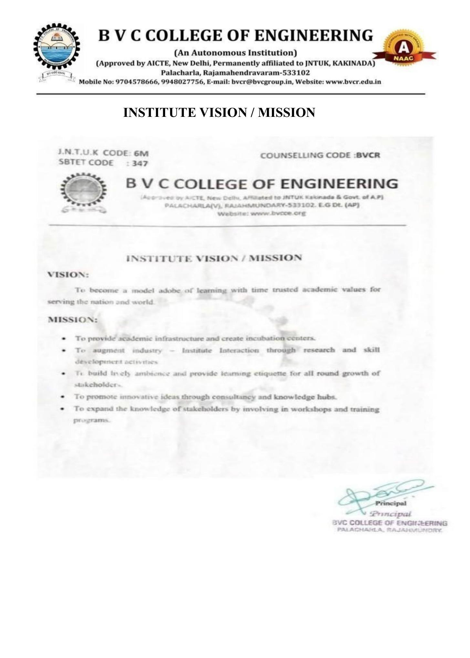
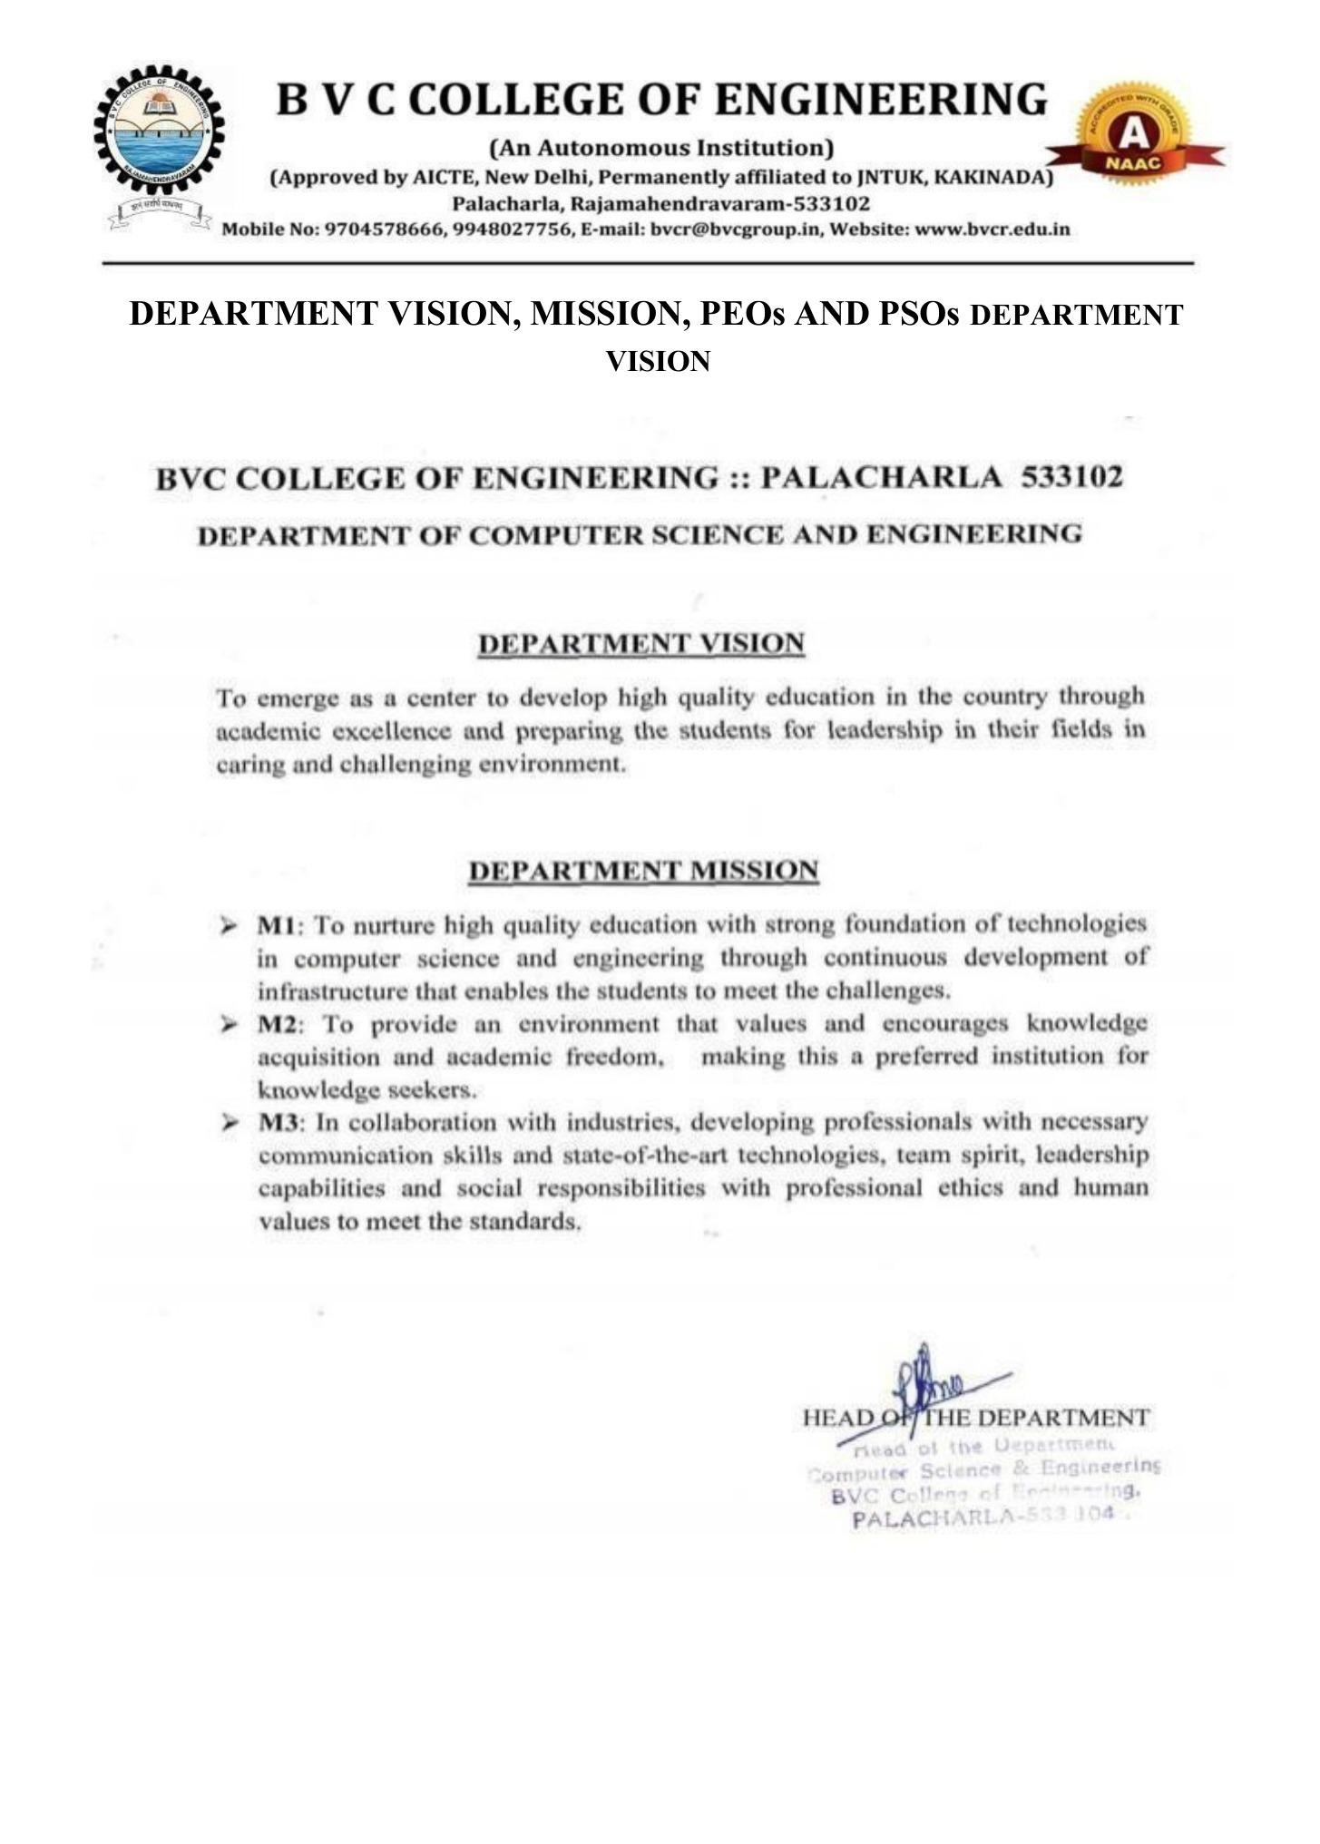
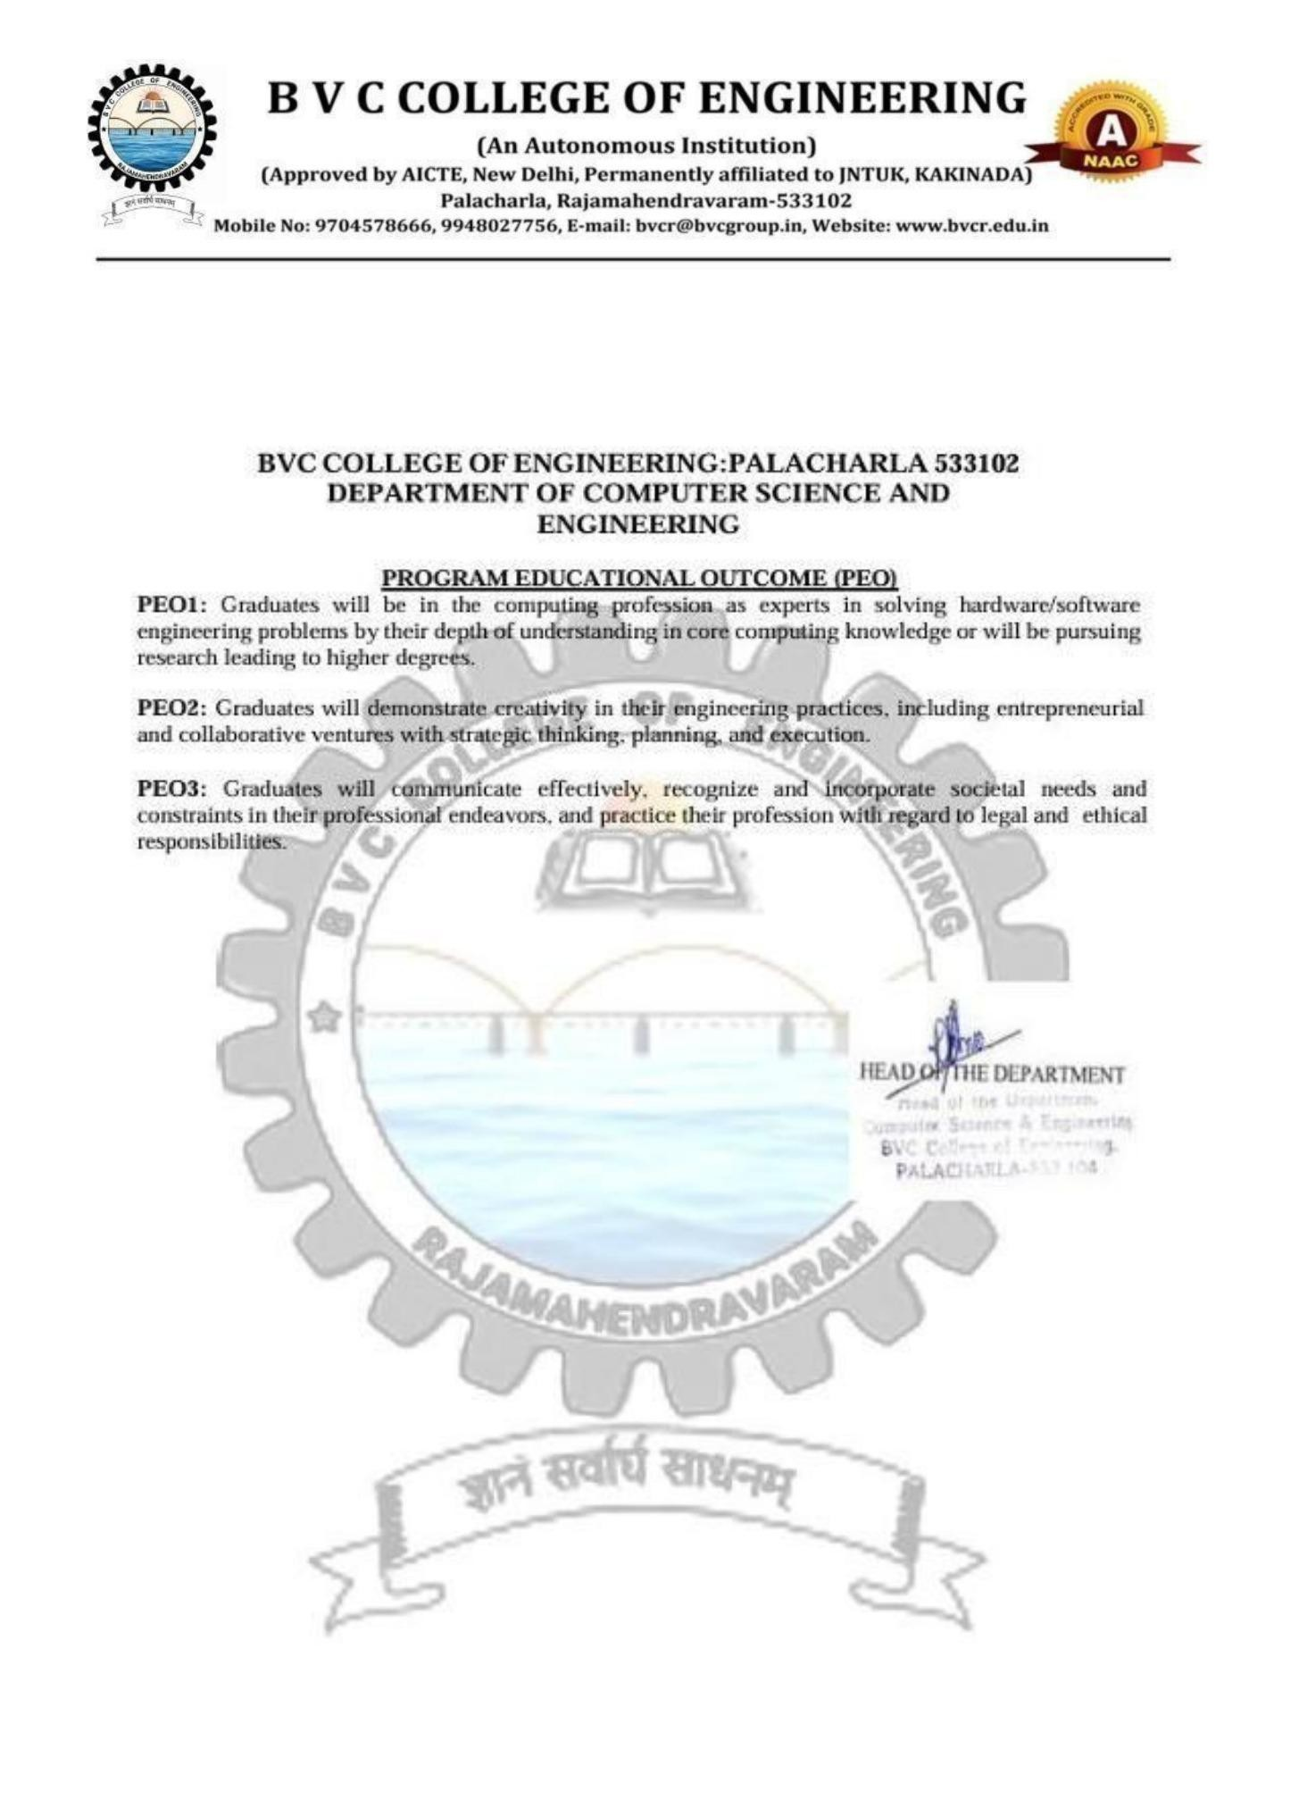
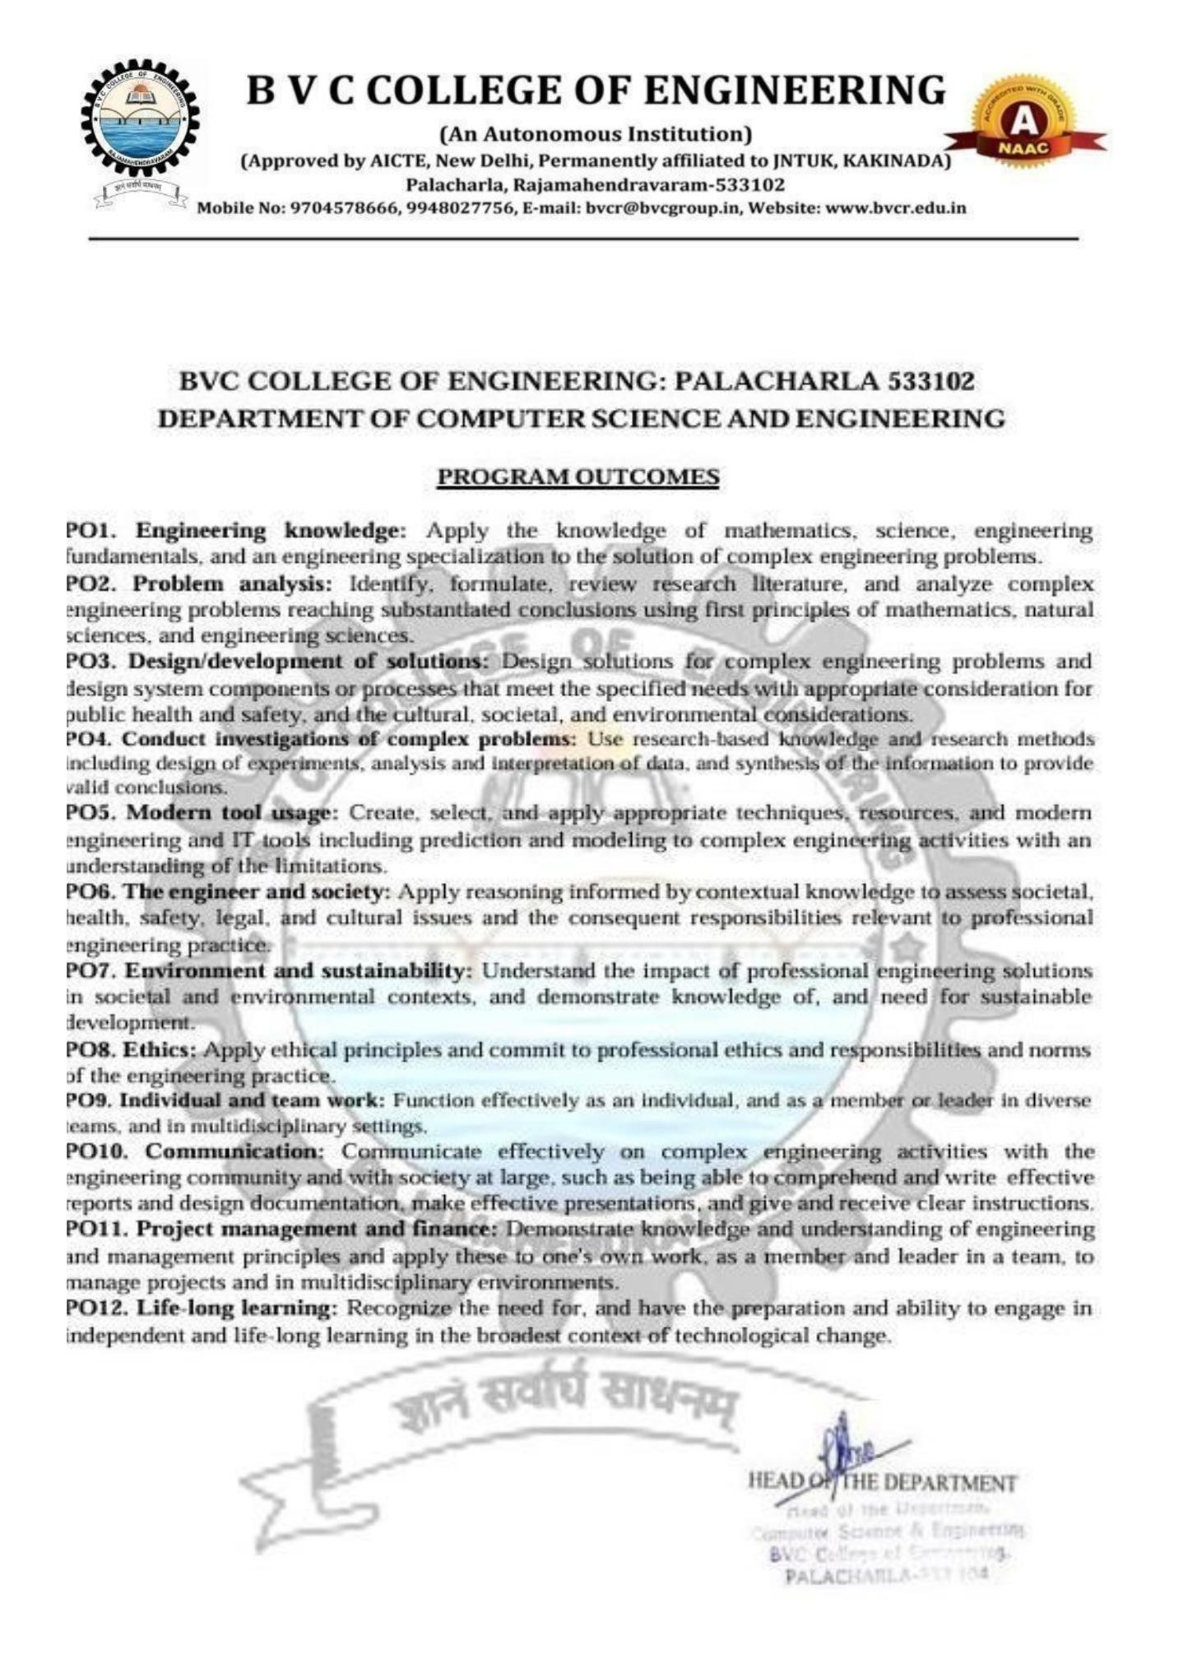
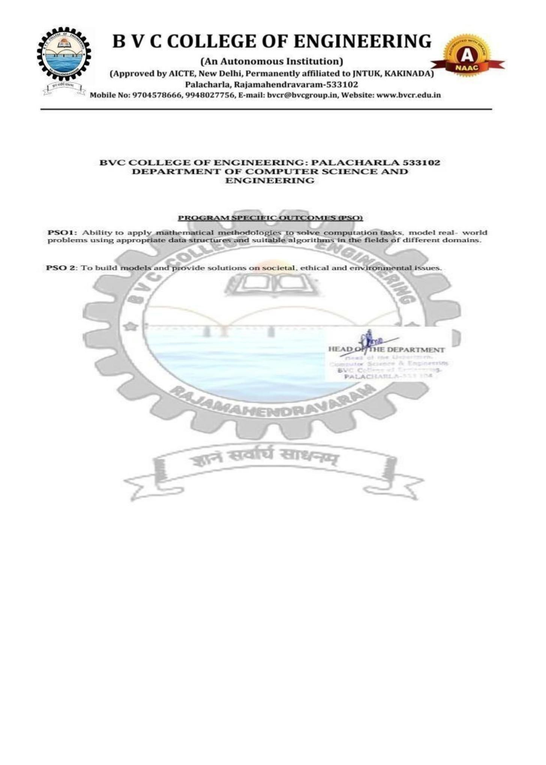

Student’s Declaration
I, SUNIL KUMAR, Reg. No. 236M1A05C1, a student of B.Tech in Computer Science and Engineering at BVC College of Engineering, hereby declare that I have successfully completed the mandatory Artificial Intelligence and Machine Learning Internship for 2 months (120 hours), organized by SmartBridge Educational Services Pvt. Ltd., in collaboration with the Andhra Pradesh State Council of Higher Education (APSCHE).

I further declare that this internship report is a genuine record of my learning, practical experience, and work carried out during the internship, submitted in partial fulfilment of the academic requirements for the award of the Bachelor of Technology degree.

Sunil Kumar
(Signature of the Student)

Certificate from Intern Organization

This is to certify that the internship report entitled "ARTIFICIAL INTELLIGENCE AND MACHINE LEARNING" is a bonafide record of work carried out by SUNIL KUMAR (Registration Number: 236M1A05C1), a student of B.Tech in Computer Science and Engineering at BVC College of Engineering, who has successfully completed a two-month internship of 120 hours, from 01 June 2026 to 31 July 2026, organized by SmartBridge Educational Services Pvt. Ltd., in collaboration with the Andhra Pradesh State Council of Higher Education (APSCHE).
The report is submitted in partial fulfilment of the academic requirements for the award of the Bachelor of Technology degree.

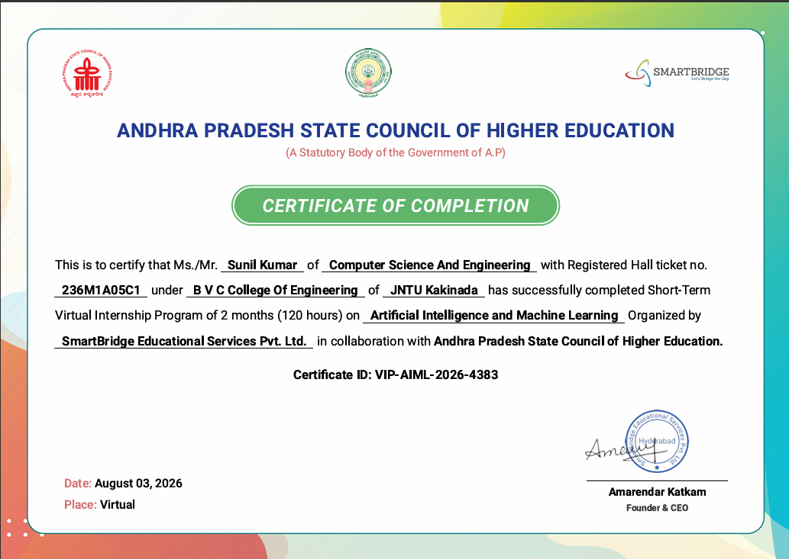

Acknowledgement
I express my sincere thanks to Dr.T.V.Janardhan Rao, Principal of BVC College of Engineering, Palacharla, for helping me in many ways throughout the period of my internship with his timely suggestions.
I sincerely owe my respect and gratitude to Mr.R.N.V.Vishnu Murthy M.Tech, MISTE, (Ph.D), Associate Professor and Head of the Department of Computer Science and Engineering for his continuous and patient encouragement during all times of my internship and for helping me in completing this study successfully.
I express my special thanks to my internal coordinator, Mrs.D.Vijaya Lakshmi M.Tech, MISTE, (Ph.D), Assistant Professor, Dept. of CSE, who extended kind support in completing my internship.
I sincerely thank SmartBridge Educational Services Pvt. Ltd. and the Andhra Pradesh State Council of Higher Education (APSCHE) for providing me with the opportunity to undergo the Short-Term Internship in Artificial Intelligence and Machine Learning.

I am grateful to all the trainers and mentors for their valuable guidance, training, and feedback throughout the internship. I also extend my heartfelt thanks to everyone who directly or indirectly supported me in successfully completing this internship and report.

SUNIL KUMAR

Contents
S.NO | TOPIC | PAGE NO
1. | EXECUTIVE SUMMARY | 12
2. | OVERVIEW OF THE ORGANIZATION | 13
3. | INTERNSHIP PART | 15
4. | ACTIVITY LOG | 16
5. | OUTCOMES DESCRIPTION | 22
6. | PROJECT WORK | 24
7. | CONCLUSION | 37
8. | REFERENCES | 24

EXECUTIVE SUMMARY
The Short-Term Internship in Artificial Intelligence and Machine Learning was organized by SmartBridge Educational Services Pvt. Ltd., in collaboration with the Andhra Pradesh State Council of Higher Education (APSCHE). The internship was completed over a period of two months, from 01 June 2026 to 31 July 2026, with a total duration of 120 hours.
The internship provided practical exposure to Artificial Intelligence, Machine Learning, Deep Learning, Generative AI and Python-based technologies. The training covered fundamental AI and ML concepts, Python programming, numerical computing, data manipulation, data visualization, data preprocessing, supervised and unsupervised learning, regression, classification, neural networks and Convolutional Neural Networks.
The technical learning activities involved tools and libraries such as Anaconda Navigator, PyCharm, NumPy, Pandas, Scikit-learn, Matplotlib and Seaborn. The program also introduced application development and deployment using Python web frameworks, including Flask and FastAPI, along with frontend and database technologies.
As part of the internship, I independently developed a project entitled "Credit Card Approval Prediction." The project focuses on applying machine learning techniques to predict whether a credit card application is likely to be approved or rejected based on applicant information. The development work involved Python-based data processing, machine learning concepts, visualization and application development.
The primary objectives of the internship were to understand AI and ML fundamentals, gain practical programming experience, learn data preprocessing techniques, explore machine learning algorithms, understand deep learning concepts and apply the acquired knowledge through an individual project.
The internship helped strengthen my understanding of Artificial Intelligence and Machine Learning and improved my practical programming, analytical thinking, problem-solving and project development skills. It also provided an opportunity to connect academic knowledge with the practical application of machine learning in the financial domain.

OVERVIEW OF THE ORGANIZATION

A. Introduction of the Organization
SmartBridge Educational Services Pvt. Ltd. is an educational technology and skill-development organization focused on connecting academic learning with industry requirements. The organization provides industry-oriented learning programs, virtual internships, technical training and project-based learning opportunities for students.
SmartBridge works with educational institutions, industry partners and government organizations to support skill development and career readiness. Its training initiatives cover emerging technology domains such as Artificial Intelligence, Machine Learning, Generative AI, Cloud Computing, Cybersecurity, Internet of Things and other technology areas.
The organization conducted the Artificial Intelligence and Machine Learning internship in collaboration with the Andhra Pradesh State Council of Higher Education (APSCHE), providing students with structured technical learning and practical project exposure.
B. Vision, Mission and Values
Vision:
To empower learners with future-ready skills and help them develop the knowledge and competencies required for professional growth and career success.
Mission:
To bridge the gap between academic education and industry expectations through industry-academia collaboration, experiential learning and technology-driven skill development.
Core Values:
- Student-focused learning and development.
- Equal access to educational opportunities.
- Industry-oriented training and practical experience.
- Innovation and continuous improvement.
- Professionalism, excellence and integrity.
- Collaboration between educational institutions and industry.
C. Policies of the Organization in Relation to the Intern Role
The internship learning process emphasizes discipline, participation and practical skill development. The following professional practices are relevant to the internship:
- Professionalism: Maintaining discipline, punctuality and professional conduct.
- Learning and Participation: Actively participating in technical sessions and practical activities.
- Project Completion: Completing assigned learning activities and project work.
- Technical Development: Applying theoretical concepts through practical exercises.
- Ethical Practices: Following responsible and ethical practices while working with data and technology.
D. Organizational Structure
The broad functional structure involved in the internship program can be described as follows:
- Management: Provides overall organizational direction and oversees operations.
- Program Coordinators: Coordinate internship schedules, learning activities and program communication.
- Technical Trainers: Conduct technical sessions and explain concepts through demonstrations.
- Mentors: Guide students during practical activities and project development.
- Interns: Participate in training, complete learning activities and develop project work.
E. Roles and Responsibilities Related to the Internship
The internship program involved guidance and technical learning through trainers, mentors and program coordinators.
The responsibilities associated with these roles include:
- Technical trainers explain concepts, demonstrate tools and provide practical exercises.
- Mentors guide students during project development and provide feedback.
- Program coordinators communicate schedules and coordinate internship activities.
- Interns participate in sessions, practise technical concepts and complete individual or assigned project activities.
F. Performance of the Organization
SmartBridge operates in the education and technology skill-development sector. Its official website describes its work in industry-academia collaboration, virtual internships, industry-aligned courses and technology-based skilling programs.
Detailed financial information such as annual turnover, profit and market valuation has not been included in this report because verified financial figures were not available from the organizational information consulted.

G. Future Plans of the Organization
Based on its stated focus on future-ready skills and industry collaboration, the organization's areas of continued development include:
- Expanding industry-aligned learning and internship programs.
- Supporting practical and project-based technical education.
- Strengthening academic and industry partnerships.
- Promoting emerging technologies and digital skills.
- Improving career readiness through mentoring and skill development.

INTERNSHIP PART
I successfully completed a two-month Short-Term Internship in Artificial Intelligence and Machine Learning at SmartBridge Educational Services Pvt. Ltd., in collaboration with APSCHE, from 01 June 2026 to 31 July 2026. The internship consisted of a total of 120 hours of technical learning and practical activities.
The internship was designed to provide knowledge of Artificial Intelligence and Machine Learning concepts and their practical applications. The learning activities covered AI fundamentals, machine learning, deep learning, Python programming, data analysis, data preprocessing, model development and application deployment.
During the internship, I studied Python programming and libraries such as NumPy, Pandas, Matplotlib, Seaborn and Scikit-learn. I also gained exposure to TensorFlow, supervised and unsupervised learning algorithms, regression, classification, artificial neural networks and Convolutional Neural Networks.
The program additionally included Generative AI learning activities, the 100K Agentblazer Champions Program and a Generative AI course with Google Cloud.
As part of the practical learning experience, I independently developed the project Credit Card Approval Prediction. The project involved applying machine learning concepts to a financial prediction problem. Python-based tools and libraries were used for data processing, model development and visualization. The application development technologies included Flask, FastAPI, React, TypeScript and SQLite, as identified for the project.
The internship helped me understand the relationship between theoretical concepts and practical implementation. It also improved my programming knowledge, analytical thinking, problem-solving skills and confidence in developing AI and ML applications.

ACTIVITY LOG

WEEKLY REPORT: WEEK 1
WEEK 1 (From 01 June 2026 to 05 June 2026)
Topic: Orientation, Generative AI and AI Fundamentals
Daily Activity and Learning Outcome:
Day | Activity | Learning Outcome
Day 1 | Platform orientation, internship objectives and introduction to the learning platform. | Understood the internship structure, learning process and program requirements.
Day 2 | Introduction to Generative AI through a technical workshop. | Gained an introductory understanding of Generative AI concepts.
Day 3 | Generative AI workshop and practical learning activities. | Explored the applications and capabilities of Generative AI.
Day 4 | Introduction to the 100K Agentblazer Champions Program. | Understood the program's learning objectives and AI-related concepts.
Day 5 | Continuation of the 100K Agentblazer Champions Program. | Developed familiarity with AI-driven technologies and learning resources.
Objective of the Activities: To understand the internship platform, become familiar with the program structure and gain introductory exposure to Artificial Intelligence and Generative AI.
WEEK 1 WORK REPORT:
The first week began with an orientation session introducing the internship platform, program objectives and learning activities. The initial sessions focused on Generative AI and its applications. The program also introduced the 100K Agentblazer Champions initiative, providing additional exposure to AI-related learning concepts.

Key Learnings
- Internship platform and program orientation.
- Introduction to Artificial Intelligence.
- Fundamentals of Generative AI.
- Applications of Generative AI.
- Introduction to the Agentblazer learning program.

WEEKLY REPORT: WEEK 2
WEEK – 2 (From 08 June 2026 to 12 June 2026)
Topic: Introduction to AI, ML, Deep Learning and Python
Daily Activity and Learning Outcome:
Day | Activity | Learning Outcome
Day 1 | Studied the history and evolution of Artificial Intelligence, along with the fundamental concepts of Machine Learning and Deep Learning. | Understood the development of AI and the basic differences between AI, ML and Deep Learning.
Day 2 | Explored Artificial Intelligence and Machine Learning applications, real-world use cases, and commonly used tools and Python packages. | Gained awareness of practical AI/ML applications and the tools used in developing intelligent systems.
Day 3 | Learned Python programming fundamentals for data science, including basic syntax, variables, data types, operators, conditional statements, loops and functions. | Developed a foundation in Python programming for data analysis and machine learning applications.
Day 4 | Introduction to NumPy, Pandas, Matplotlib and Seaborn for numerical computing, data manipulation and visualization. | Understood the importance of Python libraries in handling, analyzing and visualizing datasets.
Day 5 | Studied TensorFlow fundamentals, including tensors and basic data preprocessing concepts. | Gained introductory knowledge of TensorFlow and its role in developing deep learning applications.
The objective of the Activity Done: The objective of the second week was to understand the fundamentals of Artificial Intelligence, Machine Learning and Deep Learning, explore their real-world applications, and develop basic Python programming skills. The activities also introduced important Python libraries used for numerical computation, data analysis, visualization and deep learning.

WEEK 2 WORK REPORT:
The second week of the internship focused on understanding the fundamental concepts of Artificial Intelligence, Machine Learning and Deep Learning. On 08 June 2026, I studied the history and evolution of Artificial Intelligence and learned about the basic concepts and relationships between AI, ML and Deep Learning.

Key Learnings

History and evolution of Artificial Intelligence.

Fundamental concepts of AI, Machine Learning and Deep Learning.

Real-world applications and use cases of AI/ML.

Python programming fundamentals for data science.

Numerical computing using NumPy.

Data manipulation and analysis using Pandas.

Data visualization using Matplotlib and Seaborn.

Introduction to TensorFlow and tensors.

Basic concepts of data preprocessing.

WEEKLY REPORT: WEEK 3
WEEK – 3 (From 15 June 2026 to 19 June 2026)
Topic: Data Preprocessing, Feature Engineering & Supervised ML Algorithms
Daily Activity and Learning Outcome:
Day | Activity | Learning Outcome
Day 1 | Studied data preprocessing techniques, including handling missing values, encoding categorical data and detecting outliers. | Understood how to clean datasets and prepare data for machine learning algorithms.
Day 2 | Learned feature scaling, feature selection and train-test splitting techniques. | Understood the importance of selecting relevant features and dividing datasets for model training and evaluation.
Day 3 | Introduction to supervised and unsupervised machine learning, their characteristics and applications. | Learned the differences between supervised and unsupervised learning approaches.
Day 4 | Studied regression algorithms, including Linear Regression, Polynomial Regression, Ridge Regression and Lasso Regression. | Gained an understanding of regression techniques and their applications in predictive analysis.
Day 5 | Studied classification algorithms, including Logistic Regression, Decision Tree and Random Forest. | Understood the basic working principles of commonly used classification algorithms.
The objective of the Activity Done: The objective of the third week was to understand data preprocessing and feature engineering techniques and learn the fundamentals of machine learning. The sessions focused on preparing datasets, selecting relevant features, dividing data for training and testing, and exploring regression and classification algorithms.

WEEK 3 WORK REPORT:
The third week of the internship focused on data preprocessing, feature engineering and the fundamentals of machine learning algorithms.

Key Learnings
- Data cleaning and preprocessing.
- Handling missing values and categorical data.
- Outlier detection techniques.
- Feature scaling and feature selection.
- Train-test splitting.
- Supervised and unsupervised machine learning.
- Linear and Polynomial Regression.
- Ridge and Lasso Regression.
- Logistic Regression.
- Decision Tree and Random Forest algorithms.

WEEKLY REPORT: WEEK 4
WEEK – 4 (From 22 June 2026 to 26 June 2026)
Topic: Advanced ML Algorithms, TensorFlow & Neural Networks
Daily Activity and Learning Outcome:
Day | Activity | Learning Outcome
Day 1 | Studied advanced classification algorithms, including Support Vector Machine (SVM), K-Nearest Neighbors (KNN) and Naive Bayes. | Understood the working principles of advanced classification algorithms and their applications in predictive modelling.
Day 2 | Learned ensemble learning techniques, including Bagging, Boosting, AdaBoost and Gradient Boosting. | Gained knowledge of combining multiple models to improve prediction accuracy and model performance.
Day 3 | Introduction to Artificial Neural Networks (ANN), their architecture, neurons, activation functions and layers. | Understood the basic structure and working principles of neural networks.
Day 4 | Studied TensorFlow fundamentals, including tensors, computational graphs and building basic neural network models. | Learned the fundamentals of TensorFlow and its role in developing deep learning applications.
Day 5 | Explored neural network training concepts, including forward propagation, backpropagation, loss functions and optimizers. | Understood how neural networks learn from training data and improve prediction performance.
The objective of the Activity Done: The objective of the fourth week was to gain knowledge of advanced machine learning algorithms, ensemble learning techniques and the fundamentals of deep learning. The sessions focused on understanding advanced classification methods, combining multiple machine learning models, exploring artificial neural network architectures and learning the basics of TensorFlow for developing neural network models.
WEEK 4 WORK REPORT:

The fourth week of the internship focused on advanced machine learning algorithms, ensemble learning, TensorFlow and neural networks.

Key Learnings
- Support Vector Machine (SVM).
- K-Nearest Neighbors (KNN).
- Naive Bayes classification.
- Ensemble learning techniques.
- Bagging and Boosting.
- AdaBoost and Gradient Boosting.
- Artificial Neural Networks (ANN).
- Neural network architecture and activation functions.
- TensorFlow fundamentals.
- Forward propagation and backpropagation.
- Loss functions and optimizers.
- Neural network training concepts.

WEEKLY REPORT: WEEK 5
WEEK – 5 (From 29 June 2026 to 03 July 2026)
Topic: Deep Learning, Model Evaluation & Hyperparameter Tuning
Daily Activity and Learning Outcome:
Day | Activity | Learning Outcome
Day 1 | Studied deep learning fundamentals, deep neural networks and different types of neural network architectures. | Understood the concepts of deep learning and its applications in solving complex prediction problems.
Day 2 | Learned model training techniques, validation methods and the importance of training, validation and testing datasets. | Gained knowledge of training machine learning models and evaluating their performance using separate datasets.
Day 3 | Studied model evaluation metrics, including Accuracy, Precision, Recall, F1-Score and Confusion Matrix. | Understood how to measure classification model performance and evaluate prediction results.
Day 4 | Explored hyperparameter tuning techniques, including Grid Search and Random Search. | Learned how to optimize model parameters and improve machine learning performance.
Day 5 | Studied overfitting, underfitting, regularization techniques and cross-validation methods. | Understood how to improve model generalization and build reliable machine learning models.
The objective of the Activity Done: The objective of the fifth week was to understand deep learning concepts, model training procedures, evaluation techniques and hyperparameter optimization. The sessions focused on learning how to train machine learning models, measure their performance using evaluation metrics, optimize model parameters and prevent overfitting and underfitting.
WEEK 5 WORK REPORT:
The fifth week of the internship focused on deep learning fundamentals, model training, model evaluation and hyperparameter tuning.

Key Learnings
- Deep learning fundamentals.
- Deep neural network architectures.
- Model training and validation.
- Training, validation and testing datasets.
- Accuracy, Precision and Recall.
- F1-Score and Confusion Matrix.
- Hyperparameter tuning.
- Grid Search and Random Search.
- Overfitting and underfitting.
- Regularization techniques.
- Cross-validation methods.
- Model performance optimization.

WEEKLY REPORT: WEEK 6

WEEK – 6 (From 06 July 2026 to 10 July 2026)
Topic: ML Implementation, Dataset Analysis & Credit Card Approval Prediction Development
Daily Activity and Learning Outcome:
Day | Activity | Learning Outcome
Day 1 | Explored practical implementation of machine learning algorithms using Python, Pandas and Scikit-learn. | Gained practical knowledge of implementing machine learning algorithms using Python libraries.
Day 2 | Studied dataset collection, data loading, exploratory data analysis (EDA) and statistical analysis techniques. | Understood how to examine datasets, identify patterns and understand important data characteristics.
Day 3 | Performed practical data cleaning, missing value handling, categorical encoding and feature preparation. | Learned how to prepare structured datasets for machine learning model development.
Day 4 | Explored the implementation of classification algorithms and compared their prediction performance using evaluation metrics. | Gained practical experience in training classification models and comparing their results.
Day 5 | Initiated the Credit Card Approval Prediction project by identifying project requirements, defining objectives and planning the machine learning workflow. | Understood the project development process and established a foundation for implementing the credit card approval prediction system.
The objective of the Activity Done: The objective of the sixth week was to gain practical experience in implementing machine learning algorithms and begin the development of the individual project, Credit Card Approval Prediction. The sessions focused on dataset analysis, exploratory data analysis, data cleaning, feature preparation, classification model implementation and project requirement identification.
WEEK 6 WORK REPORT:
The sixth week of the internship focused on practical machine learning implementation, dataset analysis and the initial development of my individual project, Credit Card Approval Prediction.

Key Learnings
- Practical implementation of machine learning algorithms.
- Python libraries: Pandas and Scikit-learn.
- Dataset collection and loading.
- Exploratory Data Analysis (EDA).
- Statistical data analysis.
- Data cleaning and missing value handling.
- Categorical feature encoding.
- Feature preparation.
- Classification model implementation.
- Model performance comparison.
- Project requirement identification.
- Credit Card Approval Prediction project planning.

WEEKLY REPORT: WEEK 7

WEEK – 7 (From 13 July 2026 to 17 July 2026)
Topic: Credit Card Approval Prediction – Data Processing, Feature Engineering & ML Development
Daily Activity and Learning Outcome:
Day | Activity | Learning Outcome
Day 1 | Analyzed the Credit Card Approval Prediction dataset and examined its structure, attributes, data types and target variable. | Understood the dataset structure and identified important features required for credit card approval prediction.
Day 2 | Performed data preprocessing, including handling missing values, removing duplicate records and processing categorical and numerical features. | Learned how to improve dataset quality and prepare data for machine learning model development.
Day 3 | Applied feature engineering techniques, including categorical encoding, feature selection and feature scaling. | Understood how to transform raw data into meaningful features for improving model performance.
Day 4 | Implemented machine learning classification algorithms using Scikit-learn and prepared training and testing datasets. | Gained practical experience in training classification models for credit card approval prediction.
Day 5 | Evaluated initial machine learning models using Accuracy, Precision, Recall, F1-Score and Confusion Matrix. | Learned how to assess model performance and identify suitable classification approaches for the project.
The objective of the Activity Done: The objective of the seventh week was to process the Credit Card Approval Prediction dataset, perform feature engineering and begin developing machine learning classification models. The activities focused on understanding dataset attributes, handling missing values, transforming features, preparing training and testing datasets, implementing classification algorithms and evaluating their initial performance.
WEEK 7 WORK REPORT:
The seventh week of the internship focused on dataset processing, feature engineering and machine learning model development for my individual project, Credit Card Approval Prediction.

Key Learnings
- Credit card dataset analysis.
- Dataset structure and attribute identification.
- Missing value handling and duplicate removal.
- Numerical and categorical data processing.
- Categorical encoding.
- Feature selection and feature scaling.
- Training and testing dataset preparation.
- Scikit-learn classification algorithms.
- Initial machine learning model development.
- Accuracy, Precision and Recall.
- F1-Score and Confusion Matrix.
- Initial model performance evaluation.

WEEKLY REPORT: WEEK 8

WEEK – 8 (From 20 July 2026 to 24 July 2026)
Topic: Model Optimization, Evaluation & Frontend-Backend Integration
Daily Activity and Learning Outcome:
Day | Activity | Learning Outcome
Day 1 | Performed hyperparameter tuning and optimization of machine learning classification models using Grid Search and Random Search. | Learned how to identify suitable model parameters and improve prediction performance.
Day 2 | Compared different classification models using evaluation metrics and analyzed their prediction results. | Understood how to select an appropriate model based on classification performance and reliability.
Day 3 | Developed backend functionality using Flask and FastAPI to support machine learning model integration and prediction requests. | Gained knowledge of connecting machine learning models with backend services and handling prediction requests.
Day 4 | Worked on frontend development and connected user input forms with backend prediction functionality. | Understood how frontend components communicate with backend services to process user inputs and display prediction results.
Day 5 | Integrated the trained machine learning model with the application and performed initial functional testing. | Learned how to combine machine learning models, backend services and frontend components into a functional application.
The objective of the Activity Done: The objective of the eighth week was to optimize machine learning models, evaluate their performance and integrate the selected prediction model into the application. The activities focused on hyperparameter tuning, model comparison, backend development using Flask and FastAPI, frontend integration and initial application testing.

WEEK 8 WORK REPORT:
The eighth week of the internship focused on machine learning model optimization, performance evaluation, backend development and frontend integration for my individual project, Credit Card Approval Prediction.

Key Learnings
- Hyperparameter tuning and model optimization.
- Grid Search and Random Search.
- Classification model comparison.
- Model performance evaluation.
- Flask backend development.
- FastAPI backend development.
- Machine learning model integration.
- Frontend and backend communication.
- User input processing.
- Prediction result generation.
- Application integration.
- Initial functional testing.

WEEKLY REPORT: WEEK 9

WEEK – 9 (From 27 July 2026 to 31 July 2026)
Topic: Final Project Implementation, Testing & Documentation
Daily Activity and Learning Outcome:
Day | Activity | Learning Outcome
Day 1 | Completed the integration of machine learning models with the application and reviewed the overall project workflow. | Understood the complete workflow of the Credit Card Approval Prediction system, from user input processing to prediction generation.
Day 2 | Performed functional testing of the application, including input validation, backend communication and prediction functionality. | Learned how to identify functional issues and verify the correct operation of application components.
Day 3 | Conducted system testing and evaluated the machine learning model using performance metrics and test data. | Gained knowledge of validating system functionality and assessing prediction model performance.
Day 4 | Reviewed the application interface, corrected identified issues and organized project source code and supporting files. | Understood the importance of debugging, code organization and improving application usability.
Day 5 | Completed the project documentation, summarized the development activities and reviewed the overall Credit Card Approval Prediction project. | Gained an understanding of project documentation, development reporting and the complete machine learning project lifecycle.
The objective of the Activity Done: The objective of the ninth week was to complete the Credit Card Approval Prediction project by integrating its components, performing functional and system testing, validating model performance and preparing project documentation. The activities focused on reviewing the complete application workflow, identifying and correcting issues, organizing source code and summarizing the project development process.

WEEK 9 WORK REPORT:
The ninth week of the internship focused on final project implementation, system testing, performance validation and project documentation for my individual project, Credit Card Approval Prediction.
On 27 July 2026, I completed the integration of the machine learning model with the application and reviewed the overall project workflow. I understood how the different components work together, from processing user inputs to generating credit card approval predictions.
On 28 July 2026, I performed functional testing of the application, focusing on input validation, backend communication and prediction functionality. I learned how to verify individual application features and identify possible functional issues.
On 29 July 2026, I conducted system testing and evaluated the machine learning model using test data and performance metrics. I understood the importance of validating both application functionality and model prediction performance.
On 30 July 2026, I reviewed the application interface, corrected identified issues and organized the project source code and supporting files. I also understood the importance of debugging, maintaining organized code and improving application usability.
On 31 July 2026, I completed the project documentation and summarized the major development activities carried out during the internship. I reviewed the overall Credit Card Approval Prediction project, including dataset processing, feature engineering, machine learning model development, backend implementation, frontend integration and system testing.
Overall, the ninth week marked the completion of my internship project, Credit Card Approval Prediction. It provided practical experience in developing an end-to-end machine learning application and strengthened my understanding of the complete project development lifecycle, from initial dataset analysis to final testing and documentation.

Key Learnings
- Final machine learning model integration.
- Complete application workflow.
- Functional testing and input validation.
- Backend communication testing.
- System testing and performance validation.
- Machine learning model evaluation.
- Debugging and issue correction.
- Application interface review.
- Source code organization.
- Project documentation.
- End-to-end machine learning project development.
- Practical application of Artificial Intelligence and Machine Learning concepts.

OUTCOMES DESCRIPTION
1. Describe the Internship Environment
The internship environment provided a structured and supportive learning experience in Artificial Intelligence and Machine Learning. SmartBridge Educational Services Pvt. Ltd., in collaboration with the Andhra Pradesh State Council of Higher Education (APSCHE), organized technical learning activities that helped connect theoretical knowledge with practical applications.
The internship included technical sessions, learning modules, practical exercises and individual project development. The training activities covered Python programming, data analysis, data preprocessing, machine learning algorithms, deep learning, neural networks and application development.
The learning process encouraged independent practice, continuous improvement and the practical application of technical concepts. The available learning resources and technical guidance helped me understand different technologies and their applications in real-world problems.
Overall, the internship provided a valuable learning environment that strengthened my technical knowledge, programming abilities and confidence in developing Artificial Intelligence and Machine Learning applications.
2. Describe the Real-Time Technical Skills Acquired (In Terms of Job-Related Skills and Hands-On Experience)
During the internship, I acquired several technical skills related to Artificial Intelligence, Machine Learning, data analysis and application development.
1. Python Programming: Developed an understanding of Python programming fundamentals, including variables, data types, operators, conditional statements, loops and functions.
2. Data Analysis and Visualization: Gained practical knowledge of NumPy, Pandas, Matplotlib and Seaborn for numerical computations, dataset manipulation, statistical analysis and data visualization.
3. Data Preprocessing and Feature Engineering: Learned techniques for handling missing values, encoding categorical variables, detecting outliers, feature scaling, feature selection and train-test splitting.
4. Machine Learning Algorithms: Studied supervised and unsupervised learning approaches and explored regression and classification algorithms such as Linear Regression, Logistic Regression, Decision Tree and Random Forest.
5. Deep Learning and Neural Networks: Gained knowledge of Artificial Neural Networks, neural network architecture, activation functions, forward propagation, backpropagation and TensorFlow fundamentals.
6. Model Training and Evaluation: Learned model training procedures, performance evaluation metrics, hyperparameter tuning, cross-validation and techniques for addressing overfitting and underfitting.
7. Backend Development: Gained exposure to Python web frameworks, including Flask and FastAPI, for developing backend services and integrating machine learning functionality.
8. Frontend Development: Acquired knowledge of React and TypeScript for developing interactive user interfaces and connecting frontend components with backend services.
9. Database Management: Gained an understanding of SQLite for structured data storage and retrieval in application development.
10. Development Tools and Version Control: Used Anaconda Navigator and PyCharm for Python development and explored Git and GitHub for source code management and project organization.
11. Individual Project Development: Applied the acquired technical knowledge to independently develop the Credit Card Approval Prediction project, covering project planning, data processing, machine learning concepts and application development.
The internship activities and individual project development provided exposure to different stages of the machine learning development lifecycle, from understanding datasets to integrating prediction functionality into an application.
3. Describe the Managerial Skills Acquired
1. Project Management
- Learned to plan and organize individual project activities.
- Divided the project into different development stages.
- Established priorities for completing technical tasks.
- Followed a structured approach to project development.
2. Time Management
- Managed daily learning activities and project development tasks.
- Maintained consistency in completing weekly internship activities.
- Understood the importance of meeting project deadlines.
3. Independent Working Skills
- Developed the ability to work independently on technical assignments.
- Took responsibility for project planning, implementation and documentation.
- Improved the ability to learn new technologies through self-practice.
4. Communication and Documentation Skills
- Improved the ability to explain technical concepts.
- Developed technical documentation for project activities.
- Learned to organize project information and prepare internship reports.
- Improved the presentation of technical work.
5. Problem-Solving and Decision-Making
- Learned to identify technical problems during development.
- Explored different approaches to solving machine learning problems.
- Understood how to select suitable tools and algorithms.
- Developed analytical thinking and debugging skills.
6. Quality and Best Practices
- Understood the importance of clean and organized code.
- Learned to validate data before model development.
- Recognized the importance of model evaluation and application testing.
- Gained awareness of maintaining project files and version control.
4. Describe How You Could Improve Your Communication Skills
1. Active Participation: Participate actively in technical discussions, workshops and learning sessions to improve confidence in expressing ideas.
2. Seek and Apply Feedback: Request feedback from trainers and mentors regarding technical explanations, communication and project presentations.
3. Practise Technical Writing: Improve technical writing by preparing clear project documentation, reports, README files and code comments.
4. Improve Presentation Skills: Practise explaining project objectives, methodologies, technologies and outcomes using presentations and system architecture diagrams.
5. Practise Active Listening: Listen carefully during technical sessions, understand instructions and ask relevant questions whenever clarification is required.
6. Written Communication: Develop the ability to write clear, concise and professional emails, messages and technical reports.
7. Adapt to the Audience: Explain technical concepts using appropriate terminology for technical audiences and simpler language for non-technical audiences.
8. Continuous Learning: Participate in workshops, technical communities and hackathons to improve professional communication, confidence and knowledge sharing.

REFERENCES

The following documentation and online resources were referred to during the internship training and the development of the Credit Card Approval Prediction project.
- Python Software Foundation, Python Documentation. Available at: https://docs.python.org/3/
- NumPy Developers, NumPy Documentation. Available at: https://numpy.org/doc/
- Pandas Development Team, Pandas Documentation. Available at: https://pandas.pydata.org/docs/
- Scikit-learn Developers, Scikit-learn User Guide. Available at: https://scikit-learn.org/stable/user_guide.html
- TensorFlow Team, TensorFlow Documentation. Available at: https://www.tensorflow.org/learn
- Matplotlib Development Team, Matplotlib Documentation. Available at: https://matplotlib.org/stable/users/index
- Seaborn Developers, Seaborn Documentation. Available at: https://seaborn.pydata.org/
- Pallets Projects, Flask Documentation. Available at: https://flask.palletsprojects.com/
- FastAPI, FastAPI Documentation. Available at: https://fastapi.tiangolo.com/
- Meta Open Source, React Documentation. Available at: https://react.dev/learn
- Microsoft, TypeScript Documentation. Available at: https://www.typescriptlang.org/docs/
- SQLite Consortium, SQLite Documentation. Available at: https://www.sqlite.org/docs.html
- Git Project, Git Documentation. Available at: https://git-scm.com/doc
- GitHub, GitHub Documentation. Available at: https://docs.github.com/
- SmartBridge Educational Services Pvt. Ltd., Artificial Intelligence and Machine Learning Internship Learning Materials.
- Andhra Pradesh State Council of Higher Education (APSCHE), Internship Programme Guidelines and Learning Resources.

PROJECT WORK
PROJECT WORK
Project Name: Credit Card Approval Prediction System
Domain: Artificial Intelligence and Machine Learning – Financial Technology
Application Type: Full-Stack Machine Learning-Based Web Application
Main Concept: Predicting credit card application approval outcomes using machine learning algorithms, applicant information and an interactive web application.
Development Type: Individual Project
Backend: Python, FastAPI, Uvicorn
Frontend: React, TypeScript, Tailwind CSS
Database: SQLite
Machine Learning: Scikit-learn, XGBoost
Additional Technologies: SQLAlchemy, Alembic, Pydantic, Pandas, NumPy, Matplotlib, Seaborn, Axios, React Router, Framer Motion and Lucide React.
1. Introduction
Credit cards are widely used financial instruments that allow customers to make purchases and payments without using cash. Before issuing a credit card, financial institutions evaluate applicants using different personal, financial and credit-related factors to determine their eligibility.
Traditional credit card approval processes may involve manual verification and assessment, which can require considerable time and effort. Machine learning provides an opportunity to analyze applicant information and identify patterns that can support the credit approval process.
The Credit Card Approval Prediction System is an AI-powered web application developed to predict credit card approval decisions using machine learning algorithms. It provides an interactive platform where users can register, log in, enter applicant information and receive prediction results through a web interface.
The project combines a machine learning pipeline with a modern full-stack application. The backend is developed using Python and FastAPI, while the frontend uses React and TypeScript. SQLite is used for database management, and SQLAlchemy provides database ORM functionality.
The machine learning component uses Scikit-learn and XGBoost to support model training, comparison and prediction. The project also includes data preprocessing, validation and model performance evaluation.
The application provides user authentication, an interactive dashboard, a credit card prediction form, prediction results with confidence scores and REST API endpoints.
This project was developed individually as part of the Artificial Intelligence and Machine Learning internship. It provided practical experience in machine learning, backend API development, frontend integration and database management.
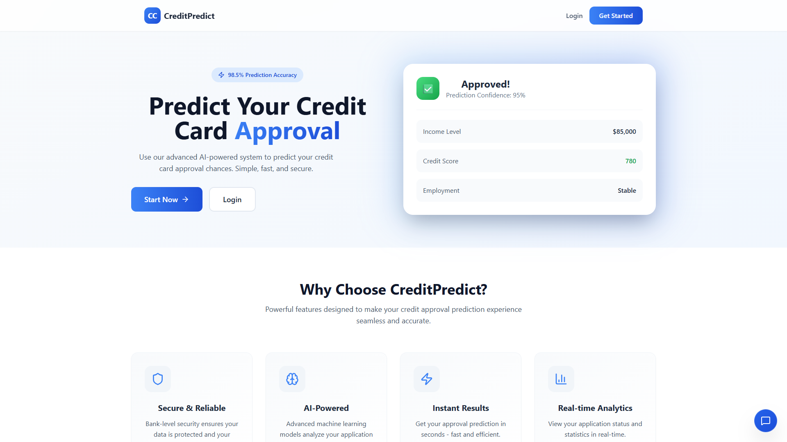
Figure 1.1: Credit Card Approval Prediction System - Modern Landing Page and Web Interface
2. Problem Statement
Credit card approval is an important process for financial institutions because they need to evaluate applicants before providing credit facilities. The assessment involves analyzing different applicant-related factors to determine whether an application satisfies the required eligibility criteria.
Manual evaluation can be time-consuming and may require considerable effort when processing multiple applications. It can also be difficult to analyze large amounts of applicant information consistently.
The problem is to develop a machine learning-based web application that accepts applicant information, processes the input and predicts the possible credit card approval outcome.
The proposed system aims to provide an interactive platform that combines machine learning prediction, user authentication, dashboard functionality and REST API communication. It is designed to support preliminary credit card application assessment rather than replace the final verification and approval procedures of financial institutions.
3. Project Objectives
The main objectives of the project are:
- To develop a machine learning-based credit card approval prediction system.
- To understand and preprocess applicant-related dataset information.
- To implement and compare multiple machine learning classification algorithms.
- To develop a model training and evaluation pipeline.
- To build REST APIs using FastAPI.
- To create an interactive frontend using React and TypeScript.
- To implement user registration and login functionality.
- To provide a dashboard for displaying application statistics.
- To integrate the machine learning prediction functionality with the web application.
- To use SQLite for application database management.
4. Existing System
Traditional credit card application assessment may involve manual verification and analysis of applicant information. This process can require considerable time and effort, especially when a large number of applications need to be evaluated.
Manual data handling may also make it difficult to maintain consistent records and analyze applicant information efficiently.
The proposed machine learning-based approach demonstrates how applicant data can be processed and analyzed using classification algorithms to generate preliminary predictions.
5. Proposed System
The proposed Credit Card Approval Prediction System is a full-stack web application that integrates machine learning functionality with a user-friendly interface.
Users can register or log in to access the application. After authentication, they can view the dashboard and navigate to the prediction page. The prediction form accepts applicant information and sends the request to the FastAPI backend.
The backend validates the submitted information and connects it with the machine learning prediction functionality. The system generates a prediction result, which is returned to the frontend and displayed to the user with a confidence score.
The application also includes a machine learning training pipeline that loads the dataset, preprocesses the data, trains multiple models, compares their performance and saves the selected model.

6. Technologies Used
Technology | Purpose
Python | Main programming language for backend development and machine learning.
FastAPI 0.115.0 | Backend framework for developing REST APIs.
Uvicorn 0.32.0 | ASGI server for running the FastAPI application.
SQLAlchemy 2.0.35 | Object-relational mapping for database operations.
Alembic 1.13.3 | Database migration management.
Pydantic 2.9.2 | Data validation and schema management.
Pandas 2.2.3 | Dataset loading, manipulation and analysis.
NumPy 2.1.3 | Numerical computations and array operations.
Scikit-learn 1.5.2 | Machine learning algorithms and preprocessing.
XGBoost 2.1.2 | Gradient boosting-based machine learning.
Matplotlib 3.9.2 | Data visualization.
Seaborn 0.13.2 | Statistical data visualization.
React 18.3.1 | Frontend user interface development.
TypeScript 4.9.5 | Type-safe frontend development.
React Router 6.26.2 | Frontend navigation and routing.
Axios 1.7.7 | Communication between frontend and backend APIs.
Tailwind CSS 3.x | Responsive interface styling.
Framer Motion | Frontend animations and interactive transitions.
Lucide React | User interface icons.
SQLite | Relational database management.
Git and GitHub | Version control and source-code management.
7. Features
7.1 User Authentication
The application provides user registration and login functionality. Users can create an account and log in to access the application's protected features.

Figure 7.1: User Authentication & Secure JWT Login Screen
7.2 Interactive Dashboard
The dashboard provides an overview of application statistics and analytics. It acts as the main interface after a user successfully logs in.
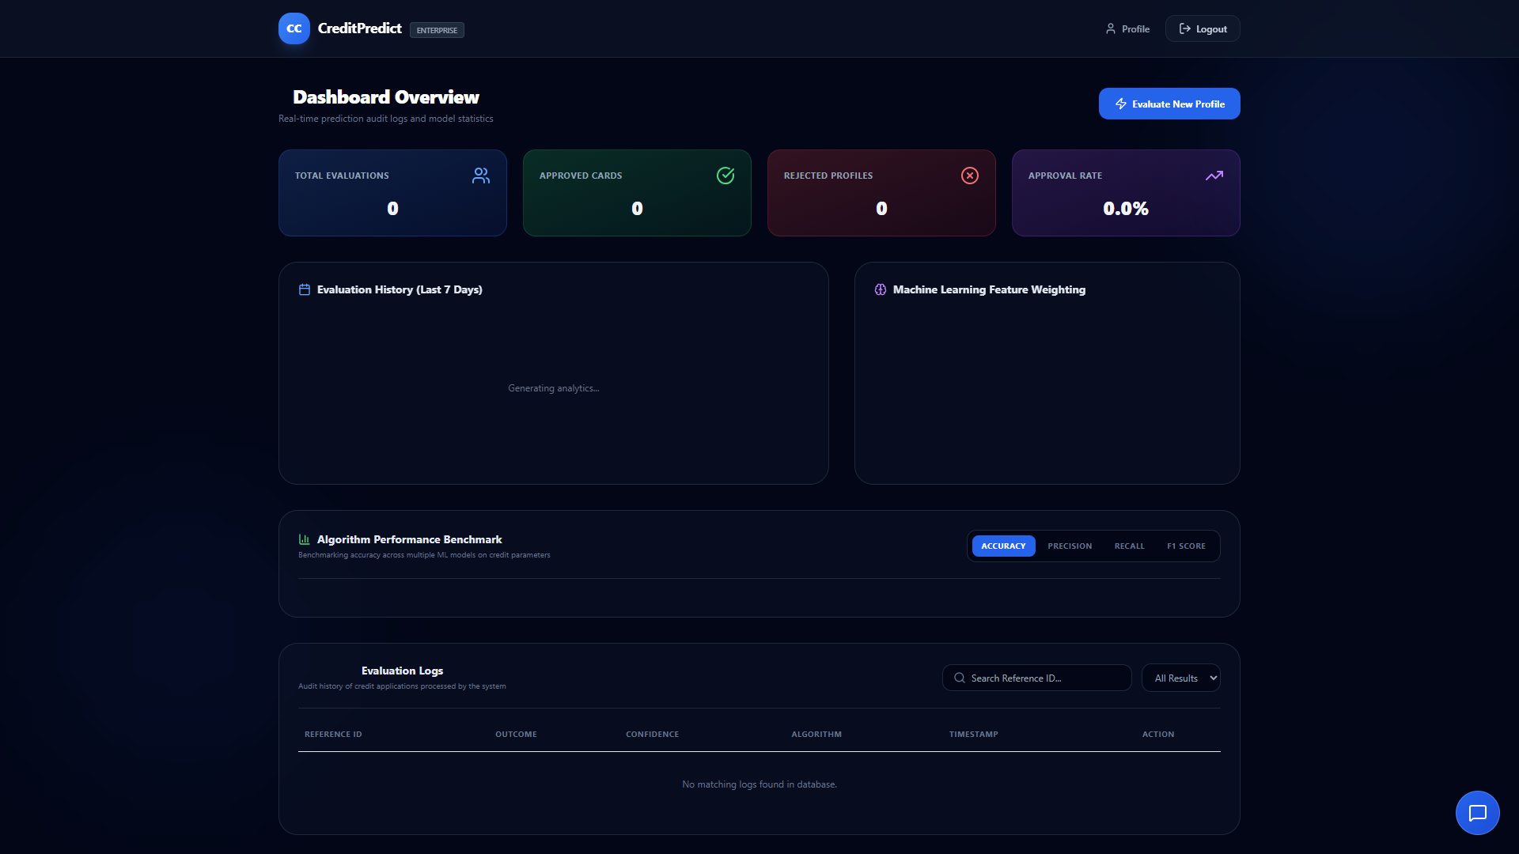
Figure 7.2: Executive Analytics Dashboard displaying Application Statistics & Model Performance Benchmarks
7.3 Credit Card Approval Prediction
The application provides an interactive prediction form where users can enter applicant-related information and request a credit card approval prediction.
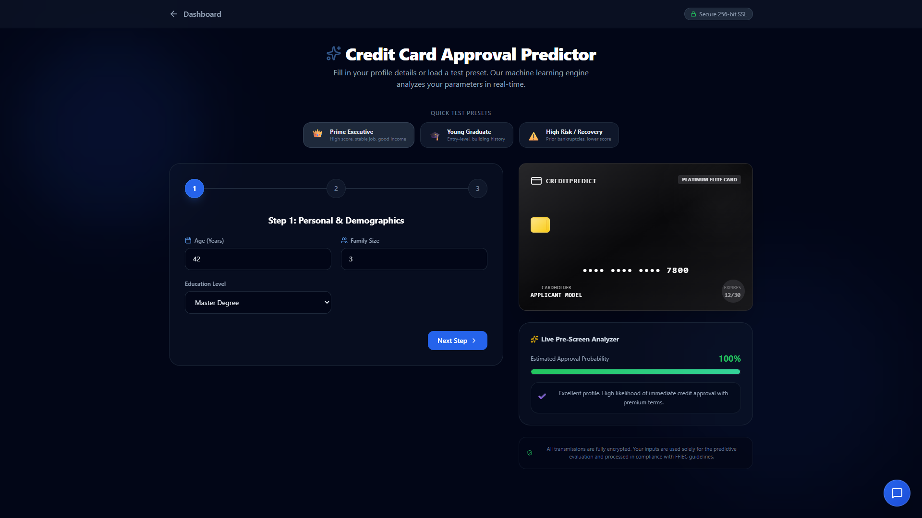
Figure 7.3: Guided Credit Application Form with Real-Time Pre-Screen Analyzer & 3D Card Mockup
7.4 Prediction Results and Confidence Scores
The system displays the generated prediction result through the frontend. The README also documents confidence scores as part of the prediction result presentation.
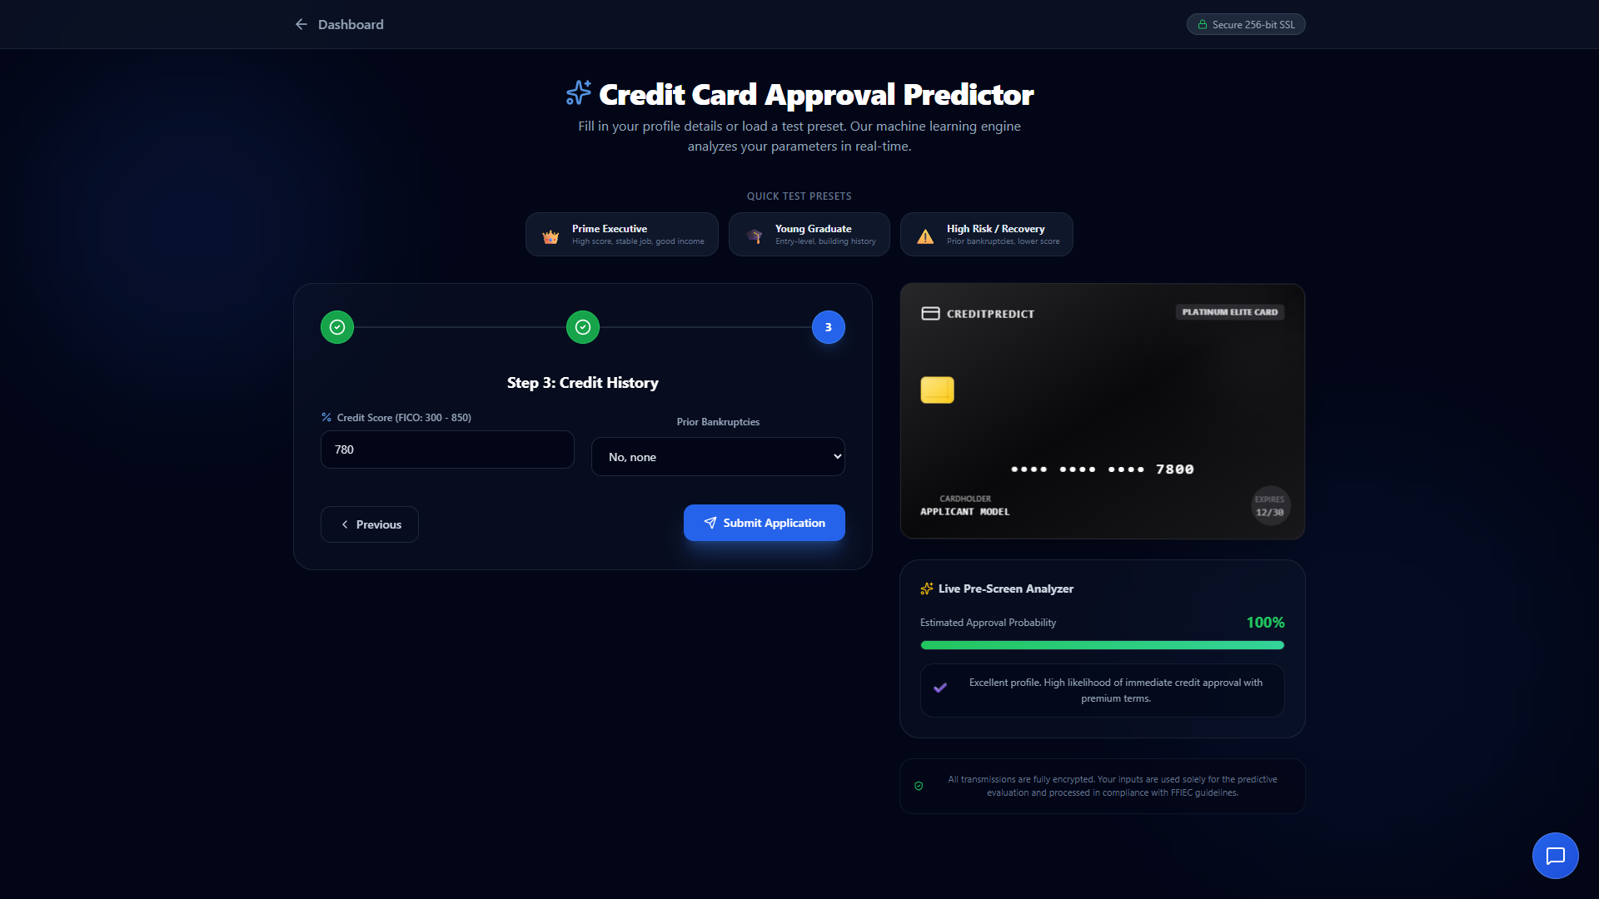
Figure 7.4: Underwriting Decision Screen with Probability Speedometer Gauge & Factor Analysis
7.5 Multiple Machine Learning Models
The machine learning component supports multiple classification algorithms, including:
- Logistic Regression
- Decision Tree
- Random Forest
- XGBoost
7.6 Model Comparison and Selection
The training pipeline trains multiple machine learning models and compares their performance. It is designed to select and save the best-performing model.
7.7 Data Preprocessing Pipeline
The system includes data loading, preprocessing and validation functionality to prepare the dataset for machine learning.
7.8 REST API Integration
FastAPI provides REST API endpoints for authentication, prediction and dashboard statistics. These APIs allow the frontend to communicate with the backend.
7.9 Responsive User Interface
The frontend uses React, TypeScript and Tailwind CSS to provide a responsive interface. Framer Motion supports interactive animations.
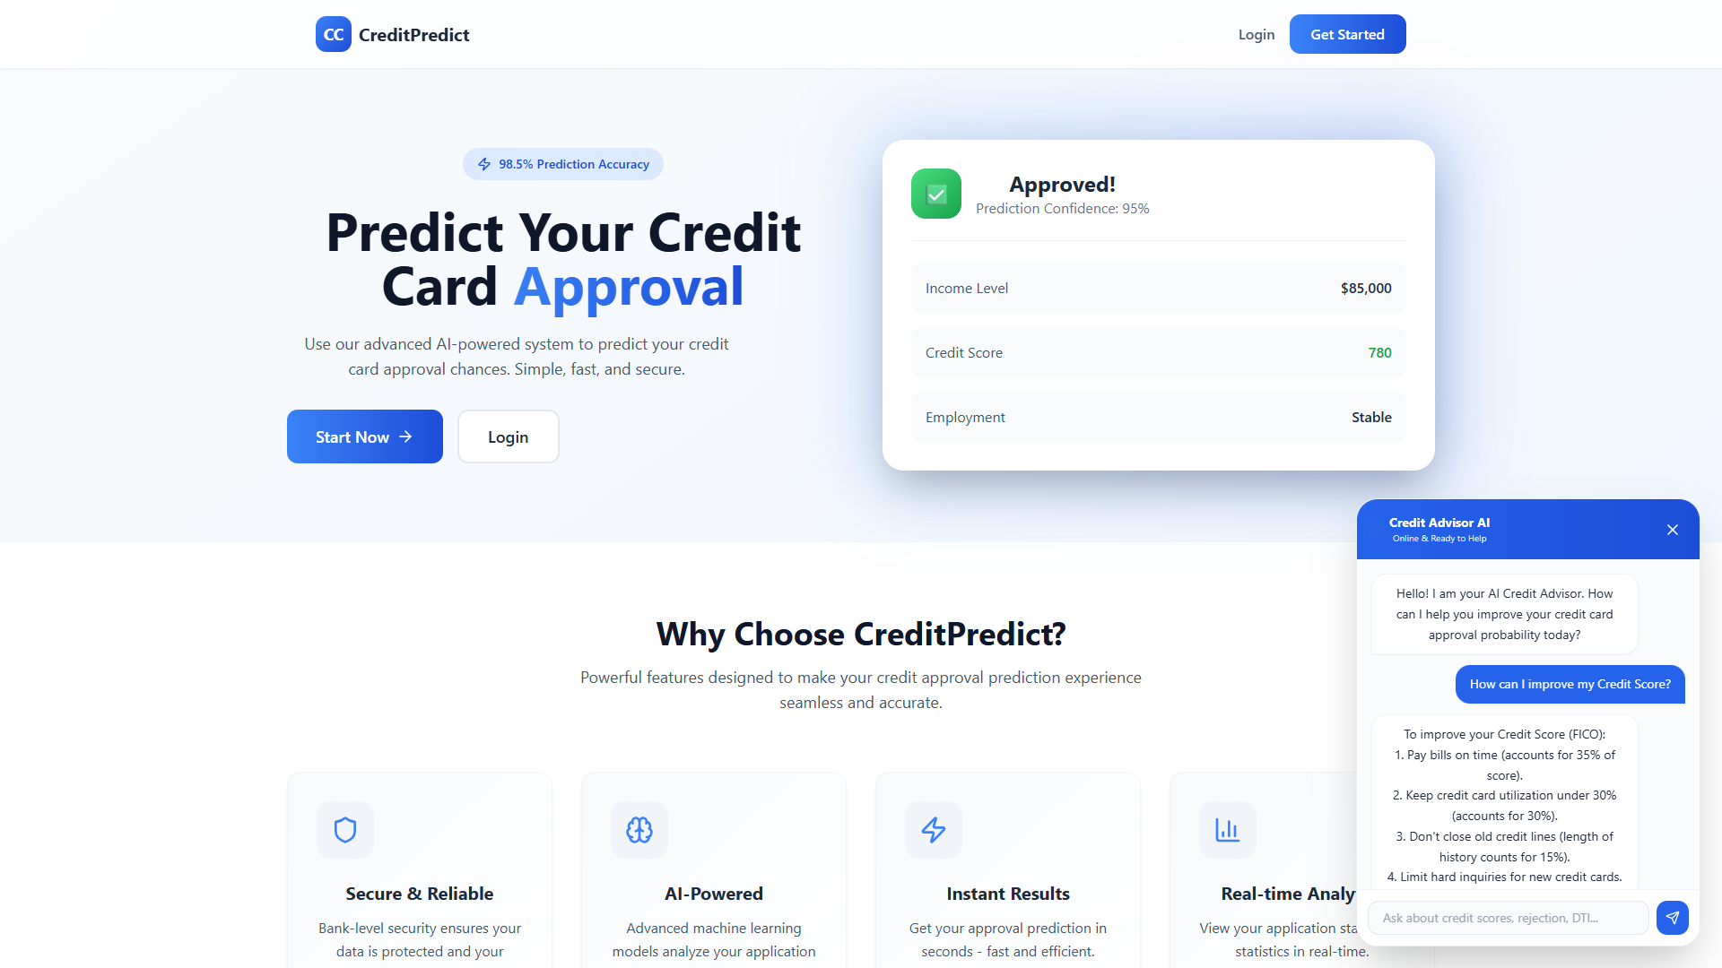
Figure 7.5: Interactive Conversational AI Credit Advisor Chat Assistant
7.10 API Documentation
FastAPI provides interactive API documentation through its documentation interface, available at /docs when the backend is running.
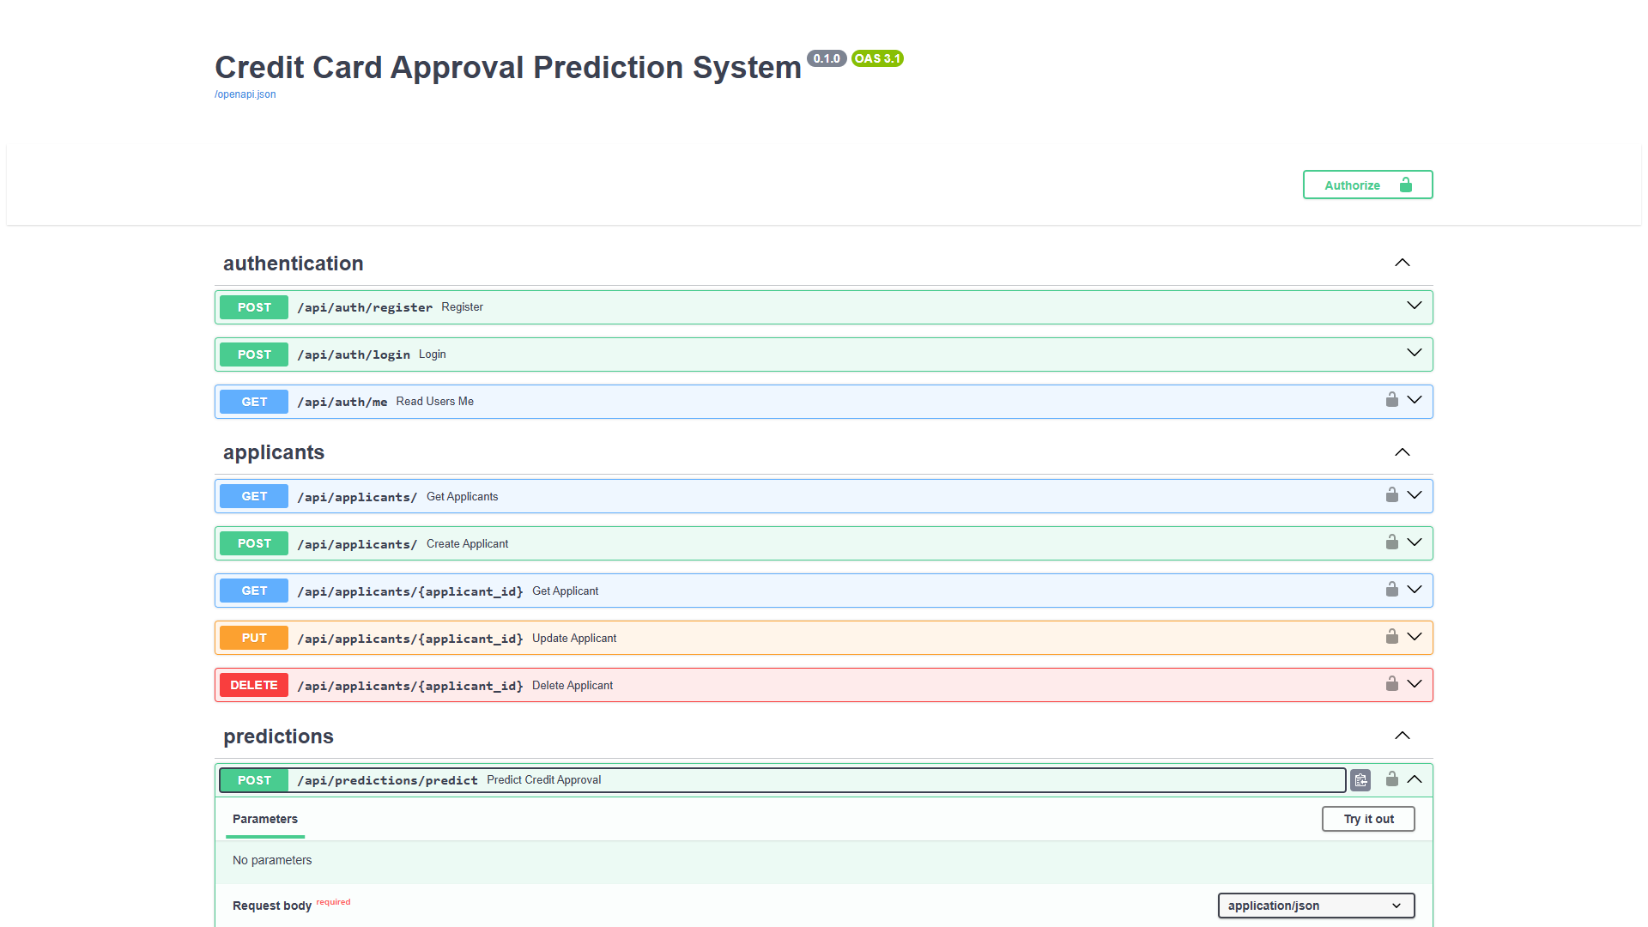
Figure 7.6: FastAPI Interactive OpenAPI (Swagger) Documentation Interface at /docs
8. Architecture and Key Design Decisions
8.1 Frontend Architecture
The frontend is developed using React and TypeScript. It is organized into reusable components, authentication context, application pages and API service modules.
React Router manages navigation between application pages, while Axios supports communication with backend APIs.
Tailwind CSS is used for interface styling, and Framer Motion supports animations.
8.2 Backend Architecture
The backend is developed using FastAPI. It contains API endpoints, configuration, database models, validation schemas and machine learning modules.
Uvicorn is used as the ASGI server to run the FastAPI application.
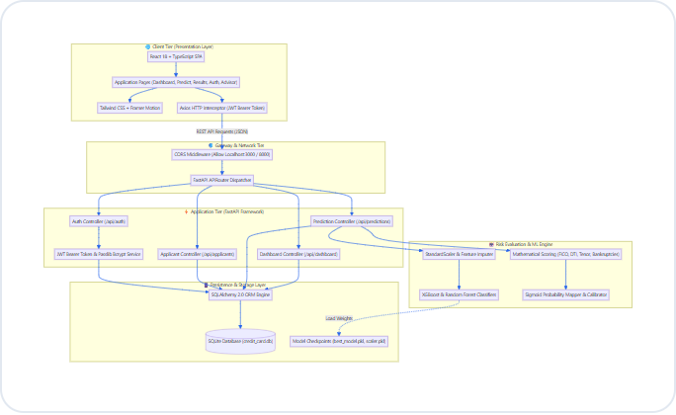
Figure 8.1: High-Level Modular System Architecture Diagram
8.3 Database Architecture
SQLite is used as the relational database. SQLAlchemy provides ORM functionality for interacting with database models, while Alembic is included for database migrations.
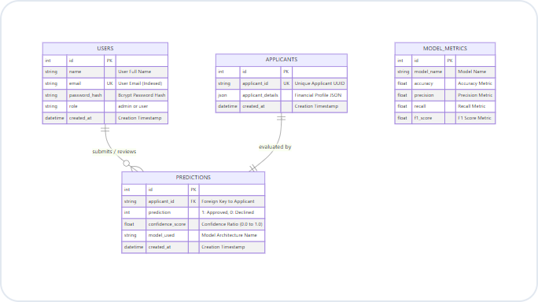
Figure 8.2: Relational Database Entity-Relationship (ER) Schema Diagram
8.4 Machine Learning Architecture
The machine learning pipeline is organized into separate modules for data loading, preprocessing and model training.
Pandas and NumPy support data preparation, while Scikit-learn and XGBoost provide machine learning algorithms.
The training pipeline is designed to compare multiple models and save the selected model for prediction functionality.
8.5 API Communication
The frontend communicates with the backend using REST APIs. Axios is used as the HTTP client to send requests and receive responses.
The backend provides endpoints for user authentication, credit card approval prediction and dashboard statistics.
9. How the System Works
- The user opens the Credit Card Approval Prediction System in a web browser.
- A new user can register, while an existing user can log in.
- After successful authentication, the application provides access to the dashboard.
- The user navigates to the credit card prediction page.
- Applicant-related information is entered into the prediction form.
- The frontend sends the prediction request to the FastAPI backend.
- The backend validates the submitted information using the defined validation schemas.
- The machine learning component processes the input using the selected trained model.
- The prediction result and confidence information are returned to the frontend.
- The result is displayed to the user through the application interface.
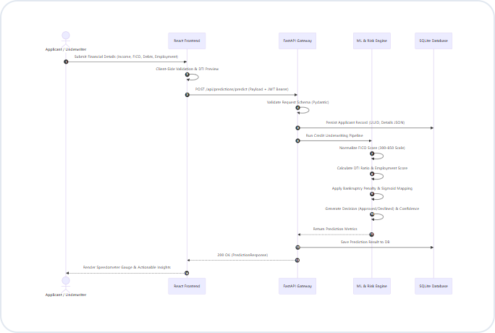
Figure 9.1: End-to-End Prediction Workflow and Communication Sequence Diagram
10. Machine Learning Methodology
10.1 Dataset Loading
The machine learning pipeline begins by loading the credit card dataset through the data-loading module.
10.2 Data Preprocessing
The preprocessing module prepares the dataset for machine learning. This stage includes the data preparation and validation operations required by the training pipeline.
10.3 Model Training
The training module implements multiple classification algorithms, including Logistic Regression, Decision Tree, Random Forest and XGBoost.
10.4 Model Comparison
The trained models are compared based on their performance. This process helps identify a suitable model for the prediction system.
10.5 Model Selection and Saving
The training pipeline selects the best-performing model and saves it in the models directory for use by the application.
10.6 Prediction
The saved model is used by the prediction functionality to process applicant information and generate the predicted approval outcome.
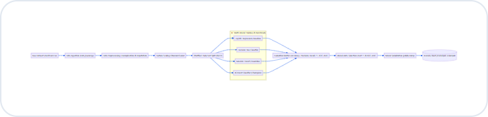
Figure 10.1: Machine Learning Model Training, Evaluation & Serialization Lifecycle
11. Project Structure
The repository is organized into backend, frontend and data-related directories.
Credit-Card-Approval-Prediction/
│
├── backend/
│ ├── app/
│ │ ├── api/
│ │ │ └── Authentication, prediction
│ │ │ and dashboard endpoints
│ │ │
│ │ ├── core/
│ │ │ └── Configuration, database
│ │ │ and authentication utilities
│ │ │
│ │ ├── models/
│ │ │ └── Database models
│ │ │
│ │ ├── schemas/
│ │ │ └── Pydantic validation schemas
│ │ │
│ │ ├── data_loader.py
│ │ ├── preprocessing.py
│ │ └── training.py
│ │
│ ├── main.py
│ └── requirements.txt
│
├── data/
│
├── frontend/
│ └── src/
│ ├── components/
│ ├── context/
│ ├── pages/
│ ├── services/
│ └── App.tsx
│
├── README.md
└── models/
The above structure follows the repository's documented architecture. The README describes the data and model storage directories but does not provide their complete internal file listing.
12. Backend Implementation
The backend is developed using FastAPI and Python. It handles application requests, authentication, prediction functionality and dashboard-related operations.
12.1 API Endpoints
The repository documents the following API endpoints:
Endpoint | Method | Purpose
/api/auth/register | POST | Registers a new user.
/api/auth/login | POST | Authenticates a user.
/api/predictions/predict | POST | Generates a credit card approval prediction.
/api/dashboard/stats | GET | Retrieves dashboard statistics.
12.2 Authentication
The application includes JWT-based authentication and role-based access control, as documented in the repository README.
12.3 Database Operations
SQLAlchemy is used for database ORM operations. Pydantic schemas support input validation, while Alembic provides database migration functionality.
12.4 Machine Learning Integration
The backend includes separate modules for dataset loading, preprocessing and model training. These modules support the machine learning workflow used by the prediction system.
13. Frontend Implementation
The frontend is developed using React 18 and TypeScript. It provides the user interface through which users interact with the application.
The frontend contains reusable components, authentication context, application pages and API service modules.
Main Frontend Components
- Components: Reusable user interface elements.
- Context: Authentication-related application state.
- Pages: Landing, login, registration, dashboard, prediction, result and profile pages.
- Services: API client configuration and backend communication.
- App.tsx: Main frontend application component.
React Router supports navigation, Axios manages API communication, Tailwind CSS provides responsive styling and Framer Motion supports animations.
14. Database Design
SQLite is used as the relational database for the project. SQLAlchemy is included to map application data to database models and support database operations.
The repository identifies a dedicated backend models directory for database models and a core directory for database configuration.
The README does not provide the exact database table names, columns or relationships. Therefore, the final database schema should be documented using the actual SQLAlchemy model definitions rather than assumed table structures.
15. How to Run the Project
The repository README provides the following setup procedure.
Prerequisites
- Python 3.8 or higher
- Node.js 16 or higher
- npm or yarn
- Git
Backend Setup
- Open a terminal in the project directory.
- Navigate to the backend folder.
cd backend
- Create and activate a virtual environment if required.
python -m venv venv
- Install the backend dependencies.
pip install -r requirements.txt
- Start the FastAPI application using Uvicorn.
uvicorn main:app --reload
The backend is available at:
http://localhost:8000
Frontend Setup
- Open another terminal.
- Navigate to the frontend directory.
cd frontend
- Install the frontend dependencies.
npm install
- Start the frontend development server.
npm start
The frontend is available at:
http://localhost:3000
Training the Machine Learning Model
To train the machine learning models, navigate to the backend application directory.
cd backend/app
python training.py
According to the README, this process loads the dataset, preprocesses the data, trains multiple machine learning models, compares their performance and saves the best model in the models directory.
API Documentation
After starting the backend, the interactive API documentation can be accessed at:
http://localhost:8000/docs
16. Testing
Testing is an important part of the Credit Card Approval Prediction System because it helps verify the functionality of the machine learning workflow and application components.
The following areas are relevant to the system's testing process:
Authentication Testing: Check user registration, login and access control functionality.
Input Validation Testing: Verify that applicant information is submitted in the required format and invalid inputs are handled appropriately.
Machine Learning Testing: Check the model training process, model comparison and prediction functionality.
API Testing: Verify the authentication, prediction and dashboard endpoints.
Frontend Testing: Check application navigation, forms, dashboard display and prediction result presentation.
Database Testing: Verify database connectivity and relevant data operations.
Integration Testing: Check communication between the React frontend, FastAPI backend and machine learning prediction component.
These testing activities provide a structured approach to evaluating the application. Actual test results and performance values should be included only after they have been verified.
17. Advantages and Limitations
Advantages
- Automates preliminary credit card approval prediction.
- Integrates machine learning with a web application.
- Supports multiple machine learning classification algorithms.
- Provides user registration and login functionality.
- Includes an interactive dashboard.
- Provides REST API-based frontend and backend communication.
- Uses SQLite for relational data management.
- Supports a modular project structure.
Limitations
- Prediction quality depends on the quality and representativeness of the dataset.
- Model predictions cannot replace complete financial verification.
- Performance may vary when applicant information differs from the training data.
- Further testing is required before using the system in a real financial institution.
- Prediction confidence should not be interpreted as a guarantee of approval.
18. Future Scope
- Improve prediction performance through additional model experimentation and optimization.
- Explore advanced ensemble learning and deep learning techniques.
- Introduce explainable AI to make prediction decisions easier to understand.
- Improve applicant information validation.
- Add more detailed prediction history and reporting functionality.
- Strengthen application security and API monitoring.
- Improve database scalability for larger applications.
- Evaluate the system using additional datasets and real-world testing.
- Study model fairness and potential bias in financial predictions.
19. Project Conclusion
The Credit Card Approval Prediction System demonstrates the application of Artificial Intelligence and Machine Learning techniques to a financial prediction problem.
The project combines a machine learning pipeline with a full-stack web application. It uses Python, FastAPI, Scikit-learn and XGBoost for backend and machine learning functionality, React and TypeScript for the frontend, and SQLite for database management.
The application includes user authentication, an interactive dashboard, a credit card approval prediction form, prediction results with confidence scores and REST API integration.
The machine learning pipeline supports dataset loading, preprocessing, model training, model comparison and model selection. These components demonstrate how machine learning techniques can be integrated into a web application to support preliminary credit card approval assessment.
Developing this project individually provided practical experience in data analysis, machine learning model development, API creation, frontend integration and database management.
Overall, the project strengthened my technical knowledge and practical understanding of Artificial Intelligence and Machine Learning applications in the financial domain.

